TITLE OF PAPER IN UPPER CASE (Times New Roman, 12 pt., centered)
Example: SOY OLEIC ACID MODIFIED INGEDE METHOD DEINKABILITY OF SOY INKJET INK PRINT

Author name¹, Author name¹, Author name²
(Example: Mehmet OKTAV¹, Efe N. GENCOGLU¹, Osman SIMSEKER²) (Times New Roman, 11 pt., centered)
(It should be underline who will present the paper)

¹ Marmara University, School of Applied Sciences, Printing Technologies, 34722, Istanbul, Turkey
e-mail: printistanbul@marmara.edu.tr

Abstract
The abstract of the paper should be written between 150-300 words. Abstract should be 12 Punto, Times New Roman.

Keywords: Keywords should be written about paper and it should be max. 5 words. (example: offset printing, screen, dot gain, color gamut, solid density)

Introduction
References should be shown with superscript according to references number. (Example: studied the formation of amino acids by the action of electric discharges on a mixture of methane, nitrogen, and water with traces of ammonia ²⁻⁴)

Experimental Part
Materials and methods used in research like machines, test devices, measure tools, paper, film, plate etc. must be indicated. At the same time test conditions, parameters and constraints must be indicated too. Obtained data should be clearly explain with figures, pictures and tables.

Conclusion
At the end of the experimental part, obtained results should be written in this part. If there are some offers about results and study it should be in this part too.

Acknowledgements
If there is any sponsor for this paper like someone, institution or organization you could thanks to him or her without advertisement.

References
References used during the preparation of the paper should be shown below the example format. References should be shown with superscript in text. Non-citation sources should not be written.

² Address of second Author (Different address)

Examples of references:

How to citation from the journals?
1. J. Lovas, R.D. Suenram and G.T. Fraser, J. Chem. Phys., 88, 722 (1988).
2. J.F. Hinton and R.D. Harpool, J. Am. Chem. Soc., 99, 349 (1997) and the references cited therein.
3. T. Buehrer, P. Gehrig, and W. Simon, Anal. Sci., (in press).

How to citation from the books?
1. World Health Organization: Industrial Pollution Control Handbook, H.F. Lund,
1971, McGraw Hill Book Co., New York, p. 4/23-4/39 (1994).
2. R.S. Houk, H.J. Svec and V.A. Fassel, “Dynamic Mass Spectrometry”, ed. D. Price
and J. F. J. Todd, 1981, Vol. 6, Chap. 19, Heyden, London, 234.
3. Black Pepper and Piperine, Encyclopedia Britannica.com, Revised March 1999.

How to citation from the papers?
1. S.P. Raghuvanshi, R. Singh, C.P. Kaushik, A.K. Raghav and A. Chandra, In Proceedings of International Conference for Water and Wastewater: Perspectives in Developing Countries (WAPDEC), International Water Association, UK, pp. 1053-1062 (2002).

How to citation from the reports?
1. American Public Health Association (APHA), Standard Methods for the Estimation
of Fluoride Ions in Water and Wastewater, Washington, DC, USA, edn. 18 (1992).
2. S.P. Raghuvanshi, M. Tech Thesis, Department of Environmental Sciences and Engineering, Guru Jambheshwar University, Hisar, Haryana, India (2001).

How to citation from the patents?
1. K.R. Anumula, US Patent 6800486 (2004).

How to citation from the web sites?
1. http://www.jstage.jst.go.jp/article/analsci/24/9/24_1073/_article (Accessed date)

The usage of tables in the paper

Table 1: Rate constant (k) for 2HI(g) H2(g) + I2(g) at absolute temperature (T) a

Ligands | log
Malic acidª | 8.828
Maleic acid^{b} | 8.550

The usage of figures and pictures in the paper
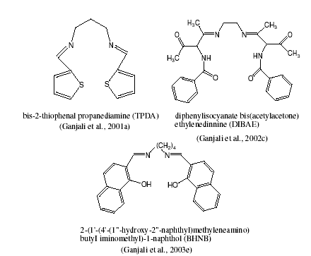
(The papers will be printed in the proceedings book. Because of these pictures must be at least 150 ppi resolution.

Figure 1: Figure name should be written

